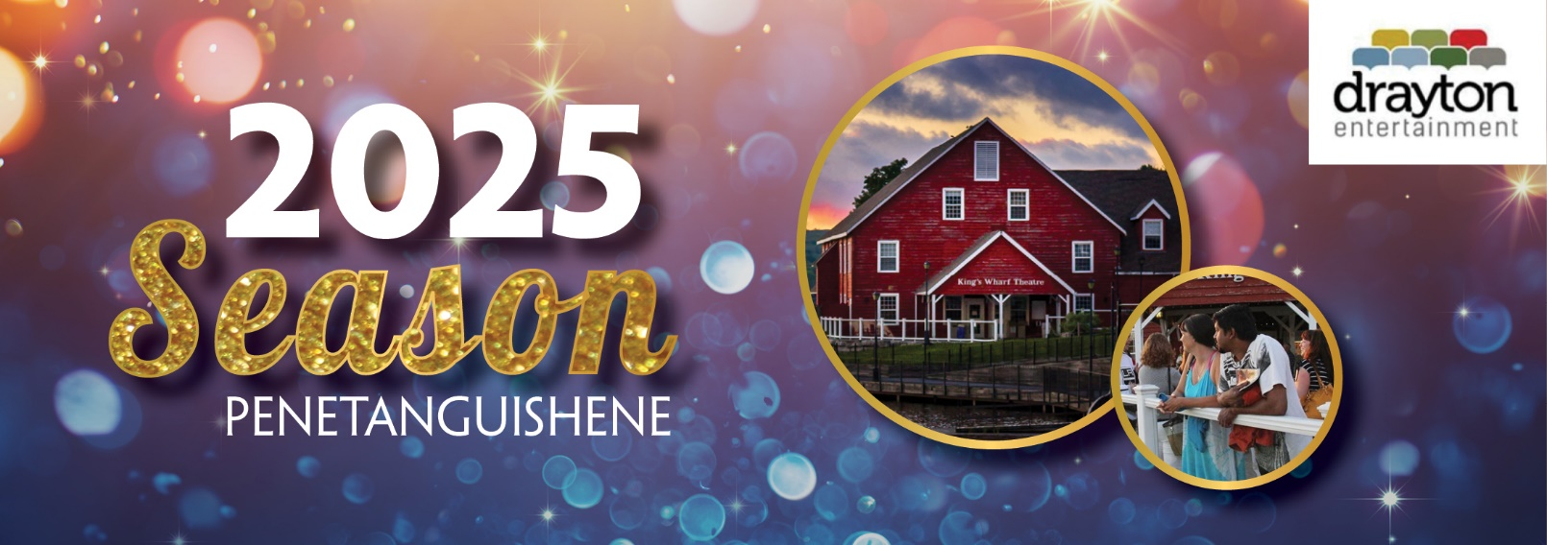

***King’s Wharf Theatre announces extraordinary***

***2025 Season***

*Smash hit Broadway musicals, heartwarming comedies, and holiday family fun set to dazzle audiences in 2025*

Friday, November 1, 2024

FOR IMMEDIATE RELEASE – The **King’s Wharf Theatre** has announced its 2025 Season featuring four productions spanning the summer and fall. Blockbuster musicals, family favourites, and a little bit of ‘greased lightnin’ will entertain audiences from **June 12** to **November 22**.

“This is an exciting season filled with entertaining shows for theatregoers of all ages,” says Alex Mustakas, Artistic Director of Drayton Entertainment. “From hit Broadway musicals, musical reviews, and the beloved annual panto, there really is something for the whole family.”

**King’s Wharf Theatre**

The 2025 Season on the shores of Georgian Bay launches with the 10-time Tony Award® - winning musical comedy, ***The Full Monty***. When a group of unemployed steelworkers are inspired to make some quick cash, they become a team of amateur male strippers with ‘real man’ bodies. This outrageously fun production is based on the Motion Picture by Fox Searchlight Pictures, with book by Terrence McNally and music and lyrics by David Yazbeck. Find out if these lovable misfits can really pull it off! This Broadway hit is on stage from **June 12** to **July 5.**

Loved by audiences in Drayton during our 2024 Season, ***Beehive: The ‘60s Musical*,** is bringing flower power AND girl power to King’s Wharf Theatre. Created by Larry Gallagher, this toe-tapping production celebrates some of the most powerful and iconic female voices of the 1960s. Told from the perspective of six women who come of age in this enigmatic decade, ***Beehive* t**akes audiences on a nostalgic journey through timeless hits of the era such as “My Boyfriend’s Back,” “Son of a Preacher Man,” and “Natural Woman”. This uplifting and upbeat salute to female empowerment is on stage **July 9** to **August 2**.

Get out your leather jackets, pull on your bobby socks, and get ready to hand jive because from **August 7** to **August 31**, ***Grease*** will be on stage in Penetanguishene. Created by Jim Jacobs and Warren Casey, this hit Broadway Musical follows the story of popular tough guy Danny Zuko and his secret summer romance with new girl Sandy Dumbrowski. Except when they come back to school, cliques and peer pressure begin to test their summer dreams. Featuring unforgettable mega-hit songs like “You’re The One That I Want,” “Hopelessly Devoted to You,” “Greased Lightnin’,” and many more! Experience this iconic musical extravaganza that will make you want to stand up and shout, “A-wop-bop-a-loo-bop A-wop-bam-boom!”.

For the final production of the 2025 Season, the long standing British panto tradition continues with the reimagined fairy tale by Caroline Smith, ***Cinderella: The Panto.*** Pantos are a popular form of family theatre in the UK based on fairy or folk tales, and encourage audience participation. With its winning combination of popular songs, energetic dancing, tongue-in-cheek humour, double entendres, innuendo, pop-culture references, and outrageous costumes, ***Cinderella*** will cast its magical spell and have you cheering for the heroine and her friends and booing the evil stepmother and wicked stepsisters. Don’t worry, we’ll have you home well before the stroke of midnight! This glittering production is on stage from **November 5** to **November 22.**

Creative teams and full casting to be announced at a later date.

**Ticket Information**

Tickets are on sale exclusively to **Members** on **Tuesday**, **November 26,** and to **Subscribers** on **Tuesday**, **December 3**. Tickets are on sale to **everyone** by phone and online at [kingswharftheatre.com](http://www.kingswharftheatre.com/) beginning on **Friday,** **December 6**. The King’s Wharf Theatre Box Office will be closed to walk-up traffic and will reopen next spring.

To order by phone, please call **705-549-5555** or toll free at **1-855-372-9866.** For more information about Drayton Entertainment’s complete 2025 Season on all seven stages, please visit draytonentertainment.com/2025.

**Season at a Glance**

**King’s Wharf Theatre**

**The Full Monty** (June 12 to July 5)

**Beehive: The ‘60s Musical** (July 9 to August 2)

**Grease** (August 7 to August 31)

**Cinderella: The Panto** (November 5 to November 22)

----

For more information, or to schedule an interview, please contact:

Danielle Dixon, Community Engagement Specialist

Phone: (519) 621-5511 ext. 256

[danielle@draytonentertainment.com](mailto:danielle@draytonentertainment.com)